The Family
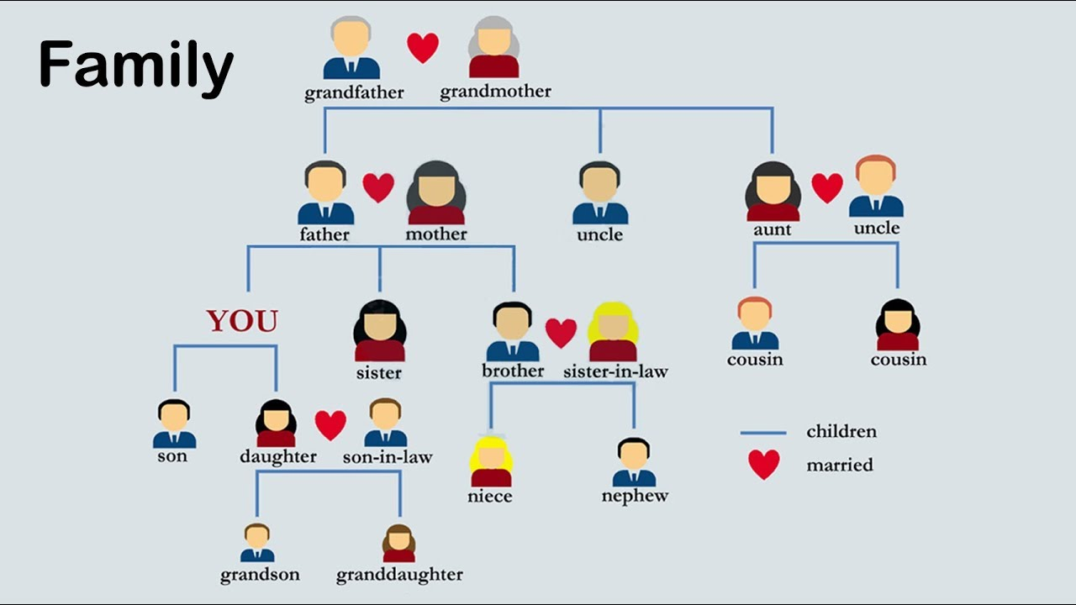

Food Vocabulary
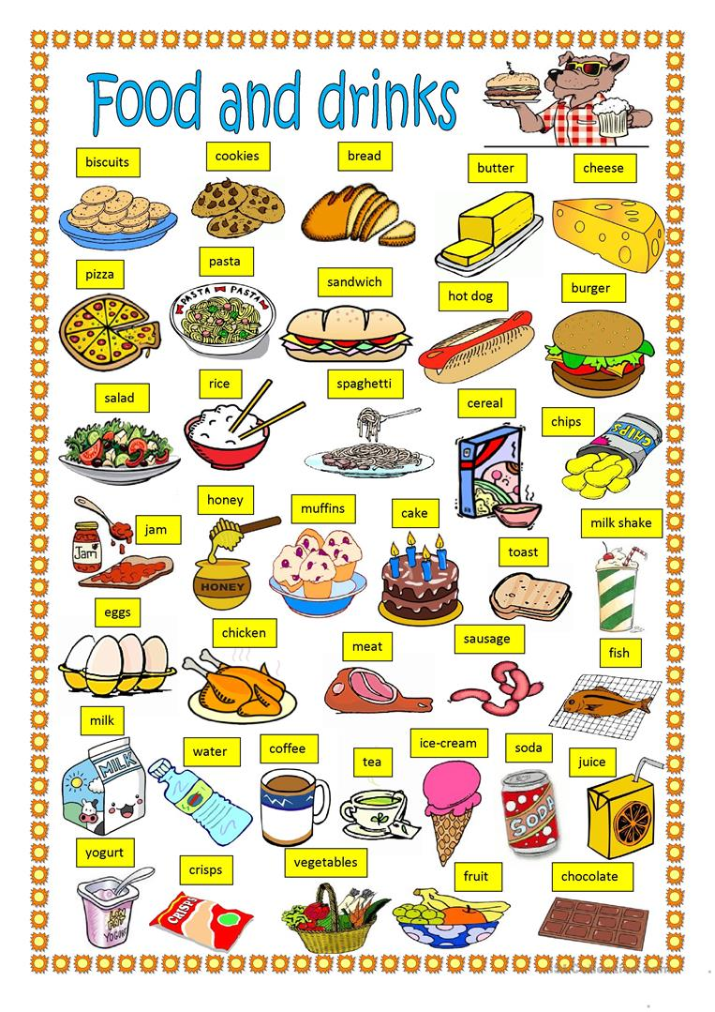
Countable and Uncountable Nouns
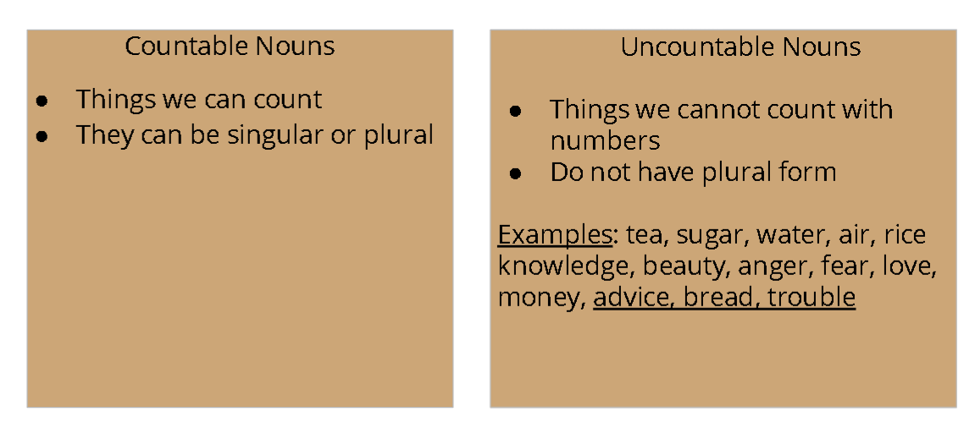
Uncountable Nouns Countable
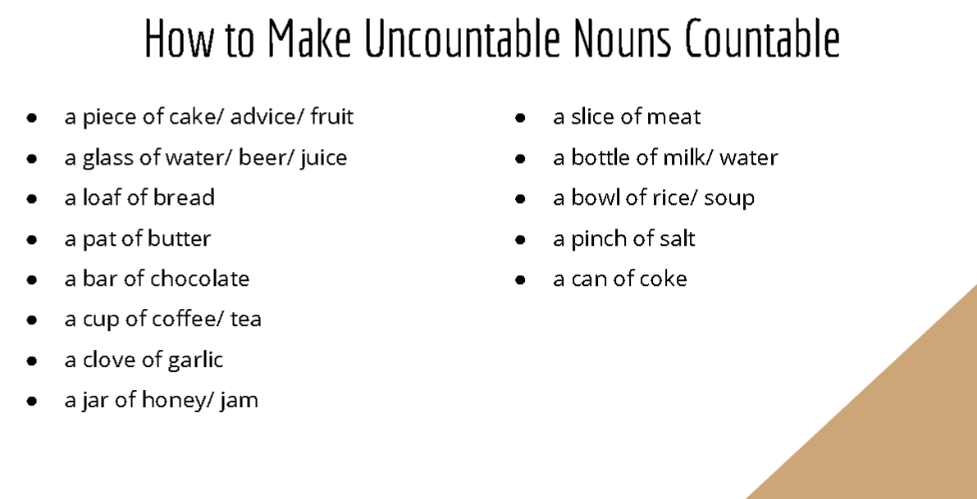

Quantifiers
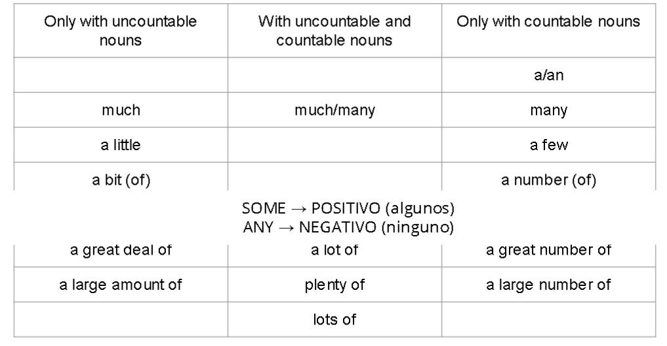
Activities:
https://es.liveworksheets.com/worksheets/en/English_as_a_Second_Language_(ESL)/Countable_and_uncountable_nouns/Countable_-_Uncountable_Nouns_rk148702hv
https://es.liveworksheets.com/worksheets/en/English_as_a_Second_Language_(ESL)/Countable_and_uncountable_nouns/Countable_-_Uncountable_nouns_kx176rx
https://es.liveworksheets.com/worksheets/en/English_as_a_Second_Language_(ESL)/Countable_and_uncountable_nouns/Some,_any,_much,_many,_a_lot_of,_how_many,_how_much_zi16153ip

Places in Town
